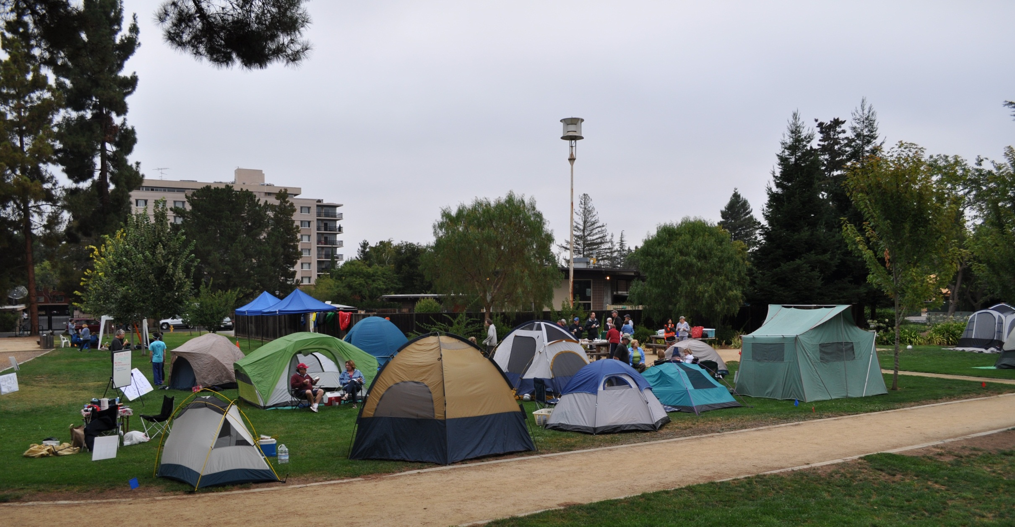Q **Quakeville 2011**

September 10th: Palo Alto

In observance of National Preparedness Month, Quakeville is a **community** exercise to emphasize the need for *personal preparedness* and *community resilience* for those living and working in the City of Palo Alto.

We will also recognize the 10th Anniversary of the 9/11 Terror Attacks in partnership with our Public Safety professionals. A 9/11 Memorial moment of silence will be held at the fire stations next to both parks at 9:11AM.

Camp Out

Campsite check-in: 1:00PM on 9/10

Campsite check-out: 11:00AM on 9/11

Choose where you want to camp:

Juana Briones Park **OR** Rinconada Park

**RSVP to Lydia Kou,** [**Lkou@apr.com**](mailto:Lkou@apr.com)

**More info about this event and more:**

[**www.paneighborhoods.org/ep**](http://www.paneighborhoods.org)

**www.cityofpaloalto.org**

Attend Demos: 2-6pm at both parks

* Palo Alto Mobile Emergency Operations Center, SWAT, Fire, and CSI vehicles [Vehicle Tours: 2:30-4pm at Juana Briones Park; then, 4:30-6pm at Rinconada Park]
* Water Filtration/Purification
* Hygiene and Sanitation
* Emergency First Aid
* Animal Psychology
* Emergency Food
* Psychological First Aid